**Name :Aditi Bandawar**

**Roll NO. :TYETA08**

***Experiment:1***

**Sum and Average of numbers:**

**Code:**

[**https://onlinegdb.com/aPvNWjcYi**](https://onlinegdb.com/aPvNWjcYi)

[**https://onlinegdb.com/gG72x83I8**](https://onlinegdb.com/gG72x83I8) **prime**

[**https://onlinegdb.com/r1dV7vyd0**](https://onlinegdb.com/r1dV7vyd0) **sum and avg**

import java.util.Scanner;

public class SumAvg {

public static void main(String[] args) {

Scanner sc=new Scanner(System.in);

System.out.println("TYETA08 Aditi Bandawar");

System.out.println("Enter a number to calculate Sum and avg: ");

int n=sc.nextInt();

float average=0;//initialization

float sum=0;

for(int i=0;i<=n;i++)//loop for sum

{

sum=sum+i;

}

average=sum/n;

System.out.println("The sum of first "+n+" numbers is: "+sum);

System.out.println("The average of first "+n+" numbers is: "+average);

}

}

**OUTPUT**

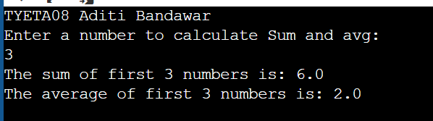

**Odd or even number**

**Code:**

import java.util.*;

public class Conditions

{

public static void main(String[] args) {

Scanner sc = new Scanner(System.in);

System.out.println("TYETA08 ADITI BANDAWAR");

System.out.println("Enter the number to check odd or even ");

int x= sc.nextInt();

if(x%2==0){

System.out.println("Even number.");

} else{

System.out.println("Odd number");

}

}

}

**OUTPUT**

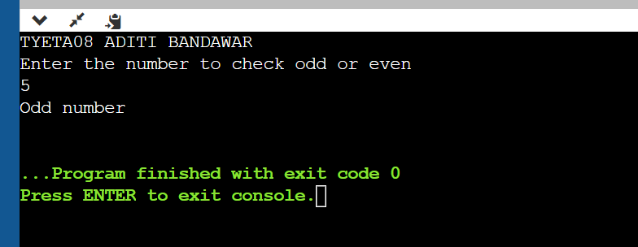

**Factorial of a number**

import java.util.*;

public class Functions{

public static void printFactorial(int n){

if(n<0){

System.out.print("Invalid Number");

return;

}

int factorial=1;

for(int i=n; i>=1;i--){

factorial=factorial*i;

}

System.out.println(factorial);

}

public static void main(String[] args) {

System.out.println("TYETA08 ADITI BANDAWAR");

Scanner sc =new Scanner(System.in);

int n= sc.nextInt();

printFactorial(n);

}

}

**OUTPUT**

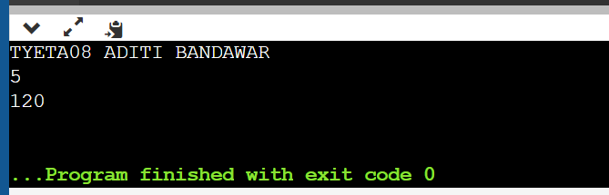

**First 50 Prime number**

**Code:**

public class primeNo {

public static void main(String[] args) {

System.out.println("TYETA08 Aditi Bandawar");

int count=0;

int num=2;

while(count<50)

{

int i;

for(i=2;i<num;i++)

{

if(num%i==0)

{

break;

}

}

if(i==num)

{

System.out.print(num+" ");

count++;

}

num++;}}}

**OUTPUT**

